

Git Assignment-29

FSE GIT Assignment



December 19, 2018

Cognizant

Kolkata

Contents

**Screenshots of the Output Step wise:** 1

**1.** **GitHub Registration:** 1

**2.** **GitHub Repository creation** 3

**3.** **Setting up GIT in Local System:** 4

**4.** **Project push into GitHub remote repository:** 5

# **Screenshots of the Output Step wise:**

## **GitHub Registration:**

Go to the URL : <https://github.com/> and register by providing username, e-mail & password.

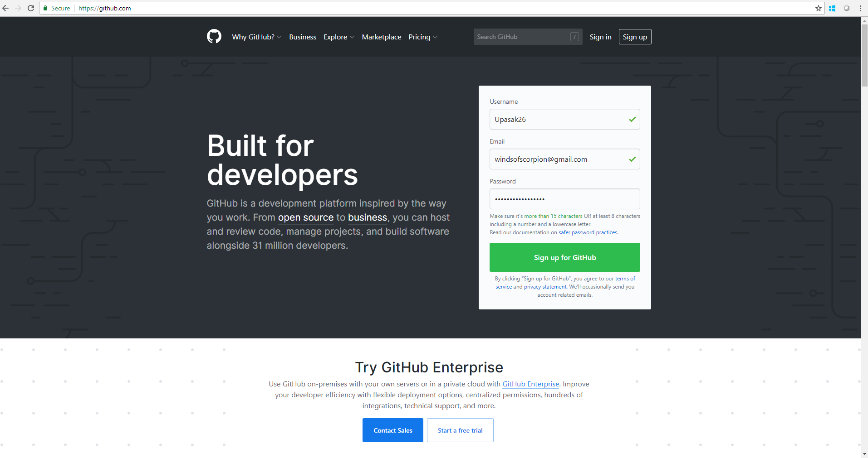

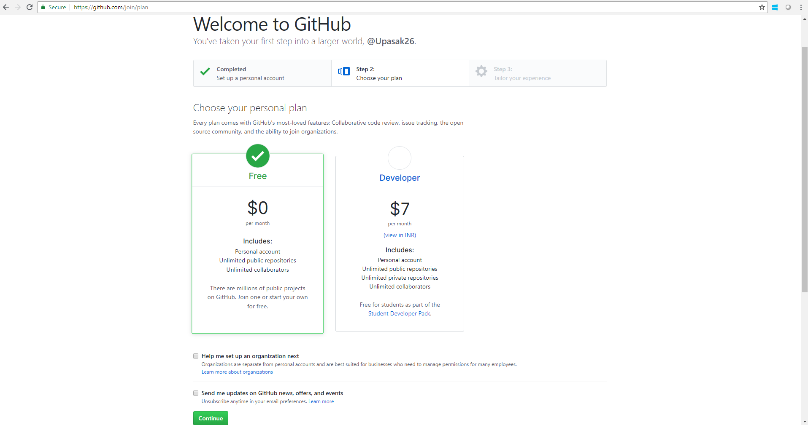

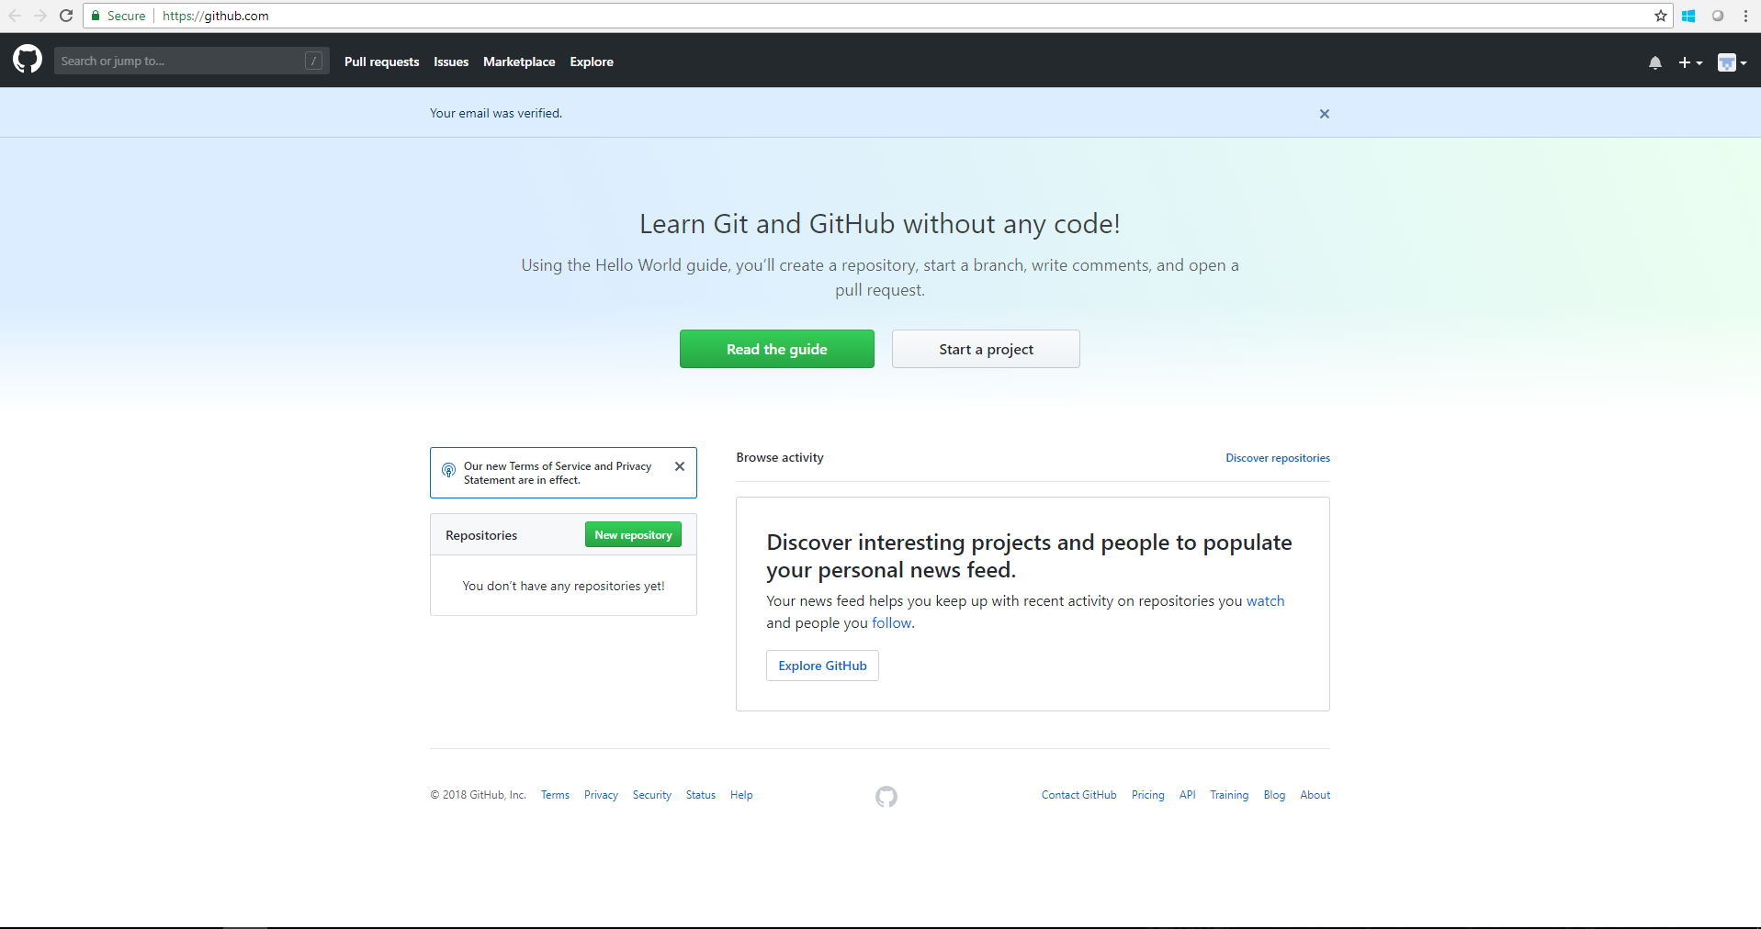

## **GitHub Repository creation**

1. Go to the GitHub home page of the newly created account.

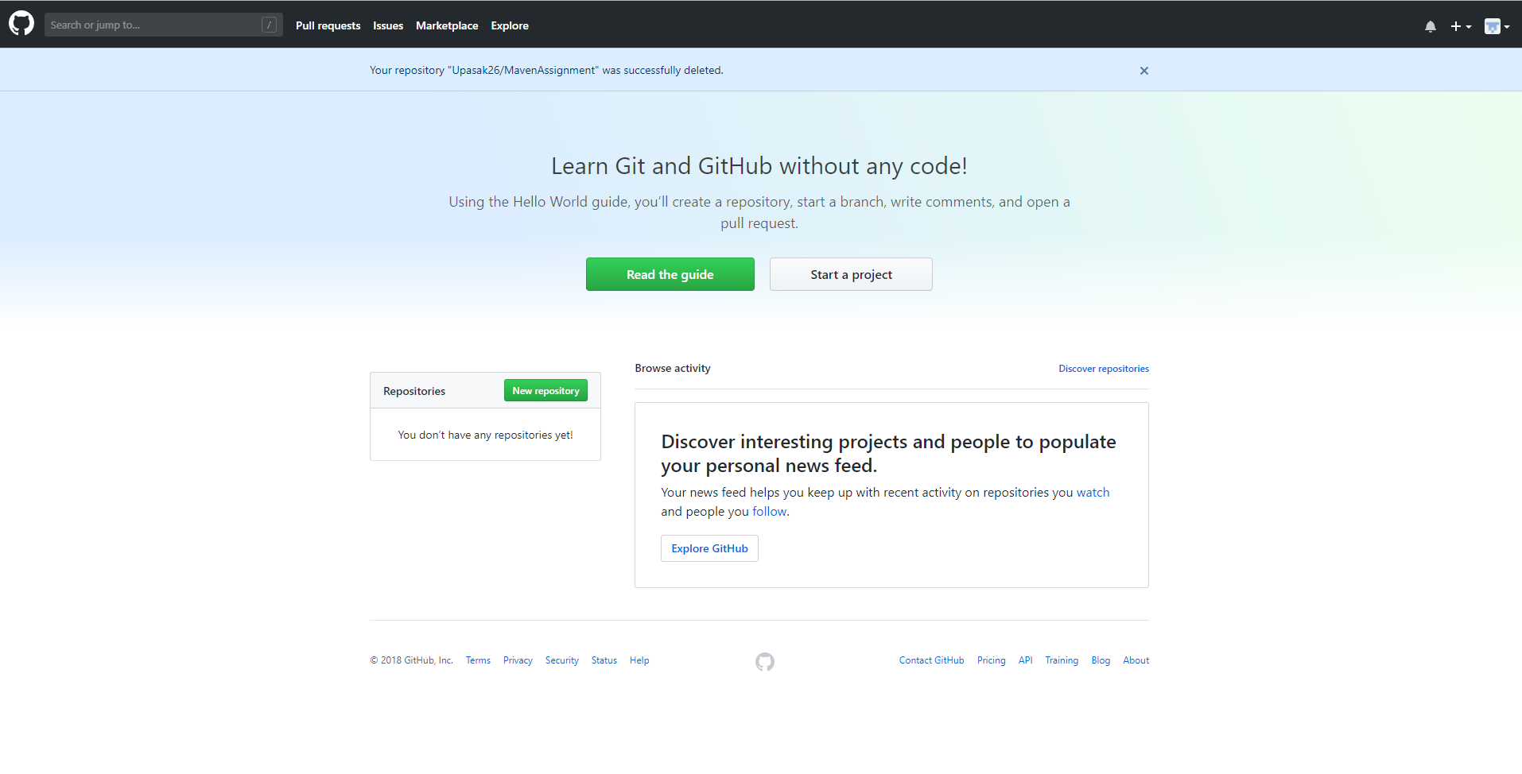

1. Click on the new repository option to get the below webpage

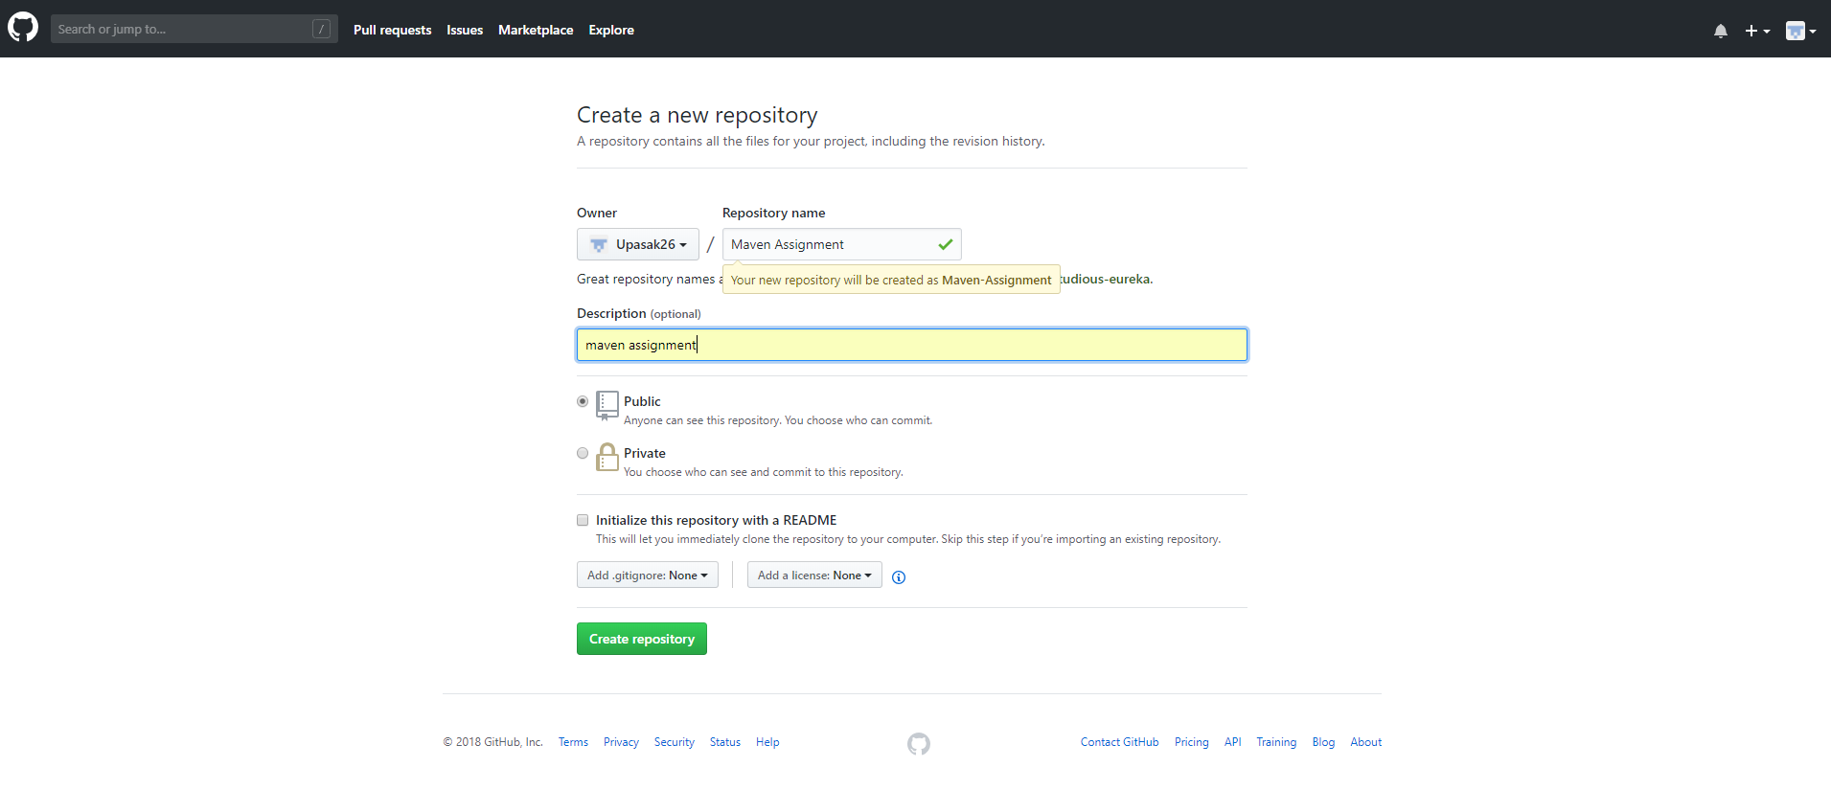

1. Fill up the repository name, description & click on create repository option to create a new repository.

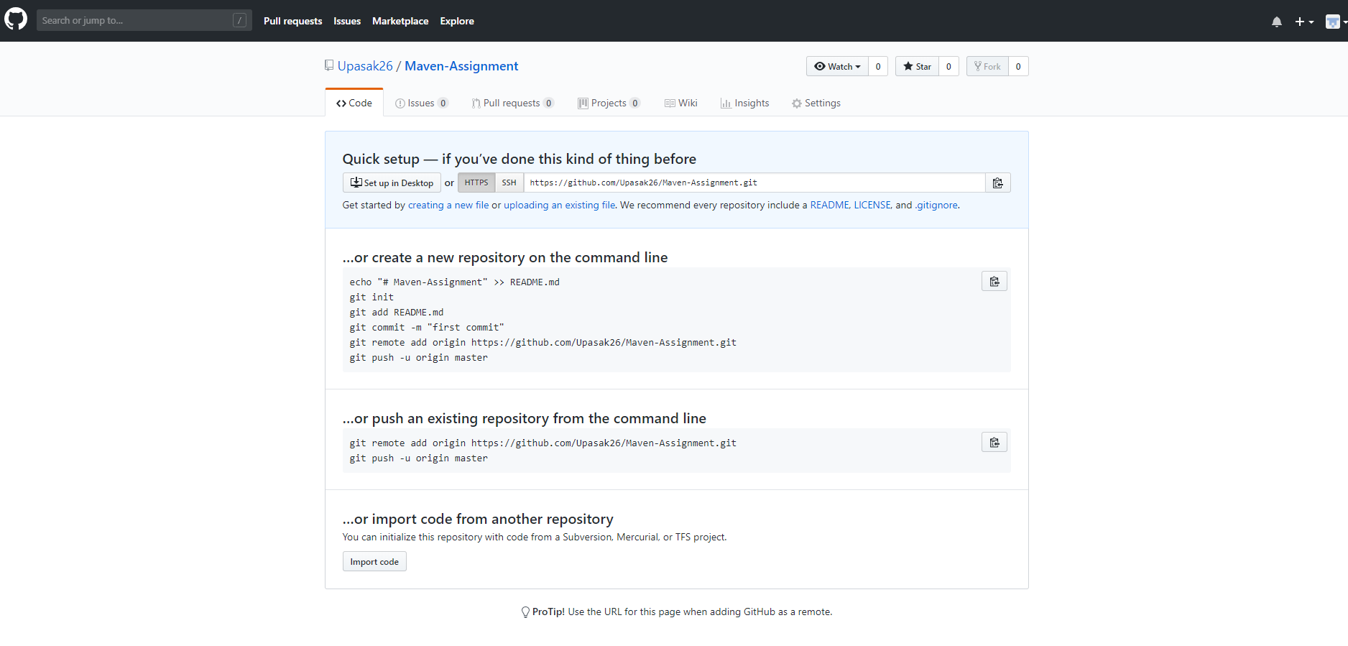

## **Setting up GIT in Local System:**

Perform the following steps to get started with Git on local system:

1. Open Git Bash.
2. Set a Git username using the command: **$ git config --global user.name "YOUR_NAME"**
3. Confirm that the Git username is set correctly: **$ git config --global user.name**

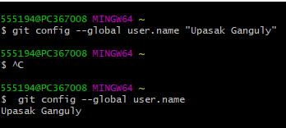

1. Set an email address in Git. You can use your GitHub-provided no-reply email address or any email address: **$ git config --global user.email “**[**email@example.com**](mailto:email@example.com)**”**
2. Confirm that you have set the email address correctly in Git: **$ git config --global user.email**





1. Change the working directory to the current directory of the spring boot project.

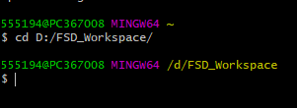

1. Create a new subdirectory named .git that contains all of your necessary repository files — a Git repository skeleton within the working directory.



## **Project push into GitHub remote repository:**

1. Use the command: **$ git add .** to add the current project files for staging

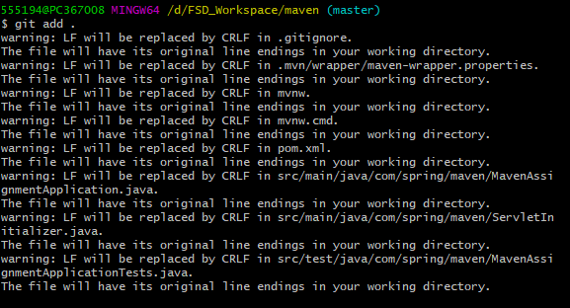

1. Commit the project files in the local repository (. git) created using the following command: **$ git commit -m 'initial project version'** Here the comment **'initial project version'** is used to distinguish it as first commit.

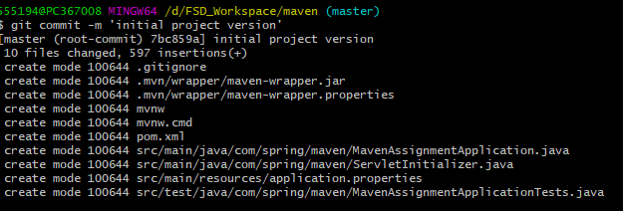

1. Add the URL of the remote GitHub repository where the local repository will be pushed using the command: **git remote add origin remote repository URL**

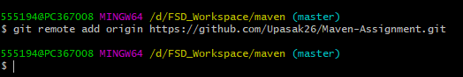

1. Finally push the spring boot project from the local to remote Git repository using the command: **$ git push origin master**